TED ISTANBUL MODEL UNITED NATIONS 2023
“Shifting Tides: Striving for Change in the Modern World”
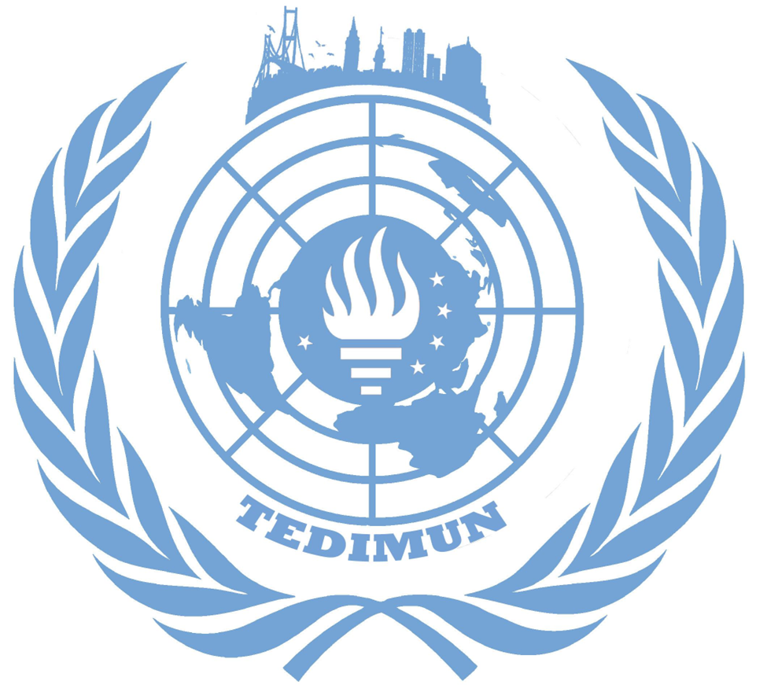
The issue of transnational organized crime
Dilay Mehmetoğlu
Deputy Chair

Committee: United Nations Office on Drugs and Crime (UNODC)
Issue: The issue of transnational organized crime
Student Officer: Dilay Mehmetoğlu - Deputy Chair
Introduction
Transnational organized crime refers to indeterminate associations which operate transnationally with the objective of seizing power, pecuniary acquisition, sphere of influence; with wholly or partially illegal practice while preserving their illicit activities through the exploitation of transnational commerce or communication mechanisms, or through a transnational organizational structure of corruption. Although there is not a precise agreement between the international instruments upon how transnational organized crime must be addressed, the omission of a precise definition is caused by the increasing perplexity and emergence of different forms of crime.
These illegal criminal networks profit from the illicit trafficking, as anonymous and complex international markets that generate tremendous monetary gains. They are estimated to generate $870 billion a year, which falls equal to 1.5 percent of the global GDP, above the sixfold of the yearly development assistance and equal to 7 percent of the world’s exports of merchandise. The erratic, ever-changing transnational organized crime industry adapts to the tides of the markets and composes unprecedented forms of crime. Due to the transcending components of the illicit industry, there are many episodes that can be characterized as transnational organized crimes such as but not limited to drug trafficking, money laundering, firearm trafficking, migrant smuggling, illegal trade of wildlife and natural resources, counterfeit goods and human trafficking.
The issue to be tackled affects the developing and developed worlds in many conspicuous and arresting aspects. The development of multilateral agreements and commissions have gained attentiveness and discretion, being in existence for some time; nevertheless the crimes encompass origins, transits and destinations which necessitate further involvement, comprehension and cooperation of the global constitutions.
Definition of Key Terms
Sphere of influence: The state of having power or authority on a region, group of people, etc.
GDP (gross domestic product): The total value of all the goods and services produced by a country in one year.
Development assistance: Governmental aid that promotes and specifically targets the economic development and welfare of developing countries.
Drug trafficking: Activities involving the cultivation, manufacture, distribution and sale of substances which are subject to drug prohibition laws.
Money laundering: The concealment of the origins of illegally obtained money by means of transfers involving legitimate businesses.
Counterfeiting: A fraudulent imitation or forgery of a product seeking to profit unfairly and illegally.
New psychoactive substances (NPS): Substances of abuse, either in a pure form or a preparation, that are not controlled under the Single Convention on Narcotic Drugs of 1961 or the 1971 Convention, but that may pose a public health threat.
Information and communication technologies (ICT): Any communication device or application, encompassing radio, television, cellular phones, computer and network hardware and software, satellite systems and so on.

General Overview
Direct Impacts
Direct impacts of transnational organized crime can be essentially defined as the reasons each criminal exercise was prohibited and constrained by the global instruments of governments. These direct impacts also emphasize on the vitality of the transnationalism of the crimes. Only when viewed globally are the net costs of these crimes apparent and only national governments monopolize the incentive to perceive globally.
Certain substances are prohibited because of their addictiveness which has an impact inevitably beyond the users control. The impact of human trafficking and interrelating images of human rights violations are impossible to quantify, regarding the inadequacy in detecting the victim. This represents an immense pool of human suffrage. Product counterfeiting impacts not just the right holders but also the receivers, since substandard or outright hazardous products pose a serious public safety threat. The profits acquired through the trafficking of natural resources cannot go unheeded as well. The crime drives ecosystems to the brink of extinction, end of life forms, an error impossible to correct or reverse.
Only if the direct impacts of transnational organized crimes are fully noticed and acquainted with through the detailed analysis of their inhibitions by the Member States, then the righteous measures can be taken.
Indirect Impacts
Indirect impacts of transnational organized crime can be defined as the undermining of the states and legitimate commercial activities, the crimes as a category execute in particular. These crimes, as mentioned in the direct impacts section, cause damage in specific forms, endangering the society and wrecking the sociocultural structure of the world. Aside from these impacts, there is a certain category that is inclusive to and valid for all: The insidious erosion of state control.
Organized crime groups displace state authority by filling the governance niches neglected by official structures and by taking control of the remaining vestigial estate agents, gradually subverting the jurisdiction and the stability of the official government. The case is the disruption and threatening of the provision of value by the organized crime groups. These structures are inherently unaccountable, not subject to democratic controls. Their predominance disables development, due to the nullification of those not to the advantage of the dominant groups.
These matters in brief are situations that the international community cannot afford to permit. Therefore, the indirect impact of the transnational organized crimes must be fully comprehended.
Forms of Transnational Organized Crime
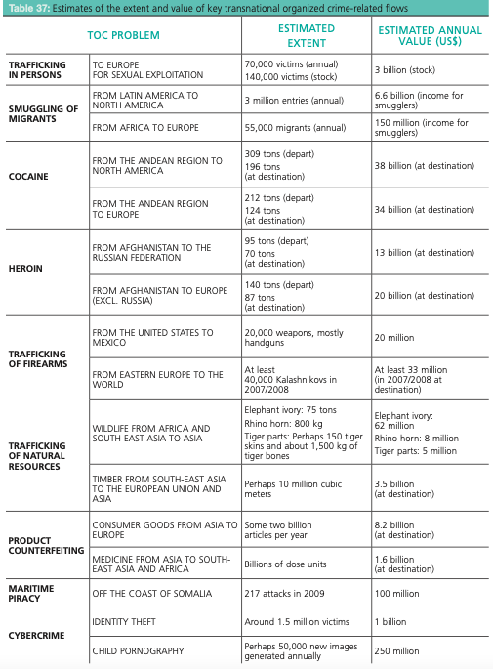
There are many different forms of transnational organized crime that surface, although there is not a consensus register of the forms of these crimes among the globe. The most enervating are such but not limited to drug trafficking, human trafficking, migrant smuggling, illicit firearms trading, trafficking of natural resources, illegal trade of wildlife, sale of counterfeit goods and cybercrime. Cybercrime is considered as a recent type of organized crime, subsequent to the late age of technology whilst drug trafficking is regarded as the most inveterate and exquisite pattern of these crimes.

Drug Trafficking
Drug trafficking is defined as the activities involving the cultivation, manufacture, distribution and sale of substances which are subject to drug prohibition laws. Regarding all the areas, the most proverbial and recognised one is drug trafficking. The United Nations Office on Drugs and Crime and the concerned governments have conducted many relevant surveys and exercises, therefore estimates can be executed with precision. As a result, many concerning trends are tracked with confidence, providing information of drug use. Although many gaps remain in the knowledge of drug markets, aggregated national and international data enables the formation of statistics and the pursuit of drug control and treatment.
Human Trafficking
Human trafficking is the recruitment, transportation, transfer or harboring of people under coercion, fraud or deluding with the aim of sexual or labor-based exploitation. Men, women and children from all around the globe are victims of this crime which is against the most basic moral principles. Although consisting of three core elements; the act, the means and the purpose; human trafficking has many forms. It is common for traffickers to engage in violent or fraudulent exercises in order to impose obligations upon their victims. An estimate from the International Labour Organization (ILO) in 2005 suggested the number of victims to be approximately 2.4 million with annual profits of nearly $32 billion, another data assessment from 111 countries and territories detected 21,400 victims worldwide in 2006. Recent research further suggests the trafficking of mostly women and children for sexual exploitation in Europe alone brings $3 billion annually and an annual flow of 70,000 victims, involving 140,000 victims at any given time. Unfortunately, the amount and reliability of these data vary greatly, due to the estimation that only one in 20 or 30 victims are ever recognised. These materials are hardly representative of the market, remaining likely that law enforcement is just skimming the surface in many regions of the globe.
Migrant Smuggling
Migrant smuggling is the facilitation of irregular ingress into a country where the migrant is not a national or a resident, for financial or other material gain. During the process, migrants’ rights are often breached, and they face many calamities such as but not limited to being robbed, raped, beaten, held for ransom; drowning, dying of dehydration, perishing or suffocation. Violence, abuse and the risk of exploitation are widespread traits of this crime, nevertheless it is a highly profitable business that broadens the reach of existing criminal networks.
Firearms Trafficking
Firearms trafficking is the unauthorized trade, purchase and transportation of firearms. This form of transnational organized crime has elastic structures and the ability to transform and be controlled from multiple locations, easily carried out by different strategies chosen on the basis of the perceived risk of detection, ease of concealment, feasibility of large payloads, geographical convenience and the vigor of border controls.
Illegal Trade of Natural Resources
Trafficking of wildlife and forest crime is the illegal exploitation of the world’s natural resources, which includes the taking, trading, importing, exporting, processing, possessing, obtaining and consuming of wild fauna and flora in contravention of national and international law. This kind of criminal poaching and trafficking enterprises carry out one of the largest transnational organized crimes, the employment of techniques and routes similar to other illicit commodities and exploitation of gaps in national law enforcement and criminal justice systems. Besides its recognition as a specialized area of organized crime, trafficking of wildlife is a significant threat to many plant and animal species, the problem particularly acute in developing countries where the regulation of the natural resources is inconsistent and irresolute.
Sale of Counterfeit Goods
Counterfeiting is the set of criminal activities that include the manufacture, export, import and distribution of illicit goods, also described as forgery; accreted by the high demand for cheap materials with low production and distribution costs. Goods such as identification documents, CDs, DVDs, electronics, software, weaponry, nutrients, clothing, tobacco and especially pharmaceuticals have expanded rapidly, the added challenge of digital piracy compounding the phenomenon.
The scale and ingenuity of the trade of counterfeits poses a formidable challenge to law enforcement authorities and all sectors of society. Many of these illicit goods, especially fraudulent pharmaceuticals, can constitute a great jeopardy to the health of the public. Moreover, counterfeiting has a vast impact on the environment. The production does not follow regulations and chemicals are disposed of unlawful and unregulated air pollution.
Major Parties Involved
INTERPOL
The International Criminal Police Organization operates as an intergovernmental organization. With 195 member countries, INTERPOL aims to aid police forces in its member states by enabling accessibility and sharing of data upon crimes and criminals, and a range of technical and operational support. The organization maintains a global security architecture and coordination between the nations, providing reinforcement especially in the challenge against transnational organized crimes.
The World Bank
The World Bank Group operates in every major development area as an aiding and ensuring organization. It provides a wide array of financial products and technical assistance, also contributes during applications of innovative knowledge and solutions to the challenges that are faced.
International Monetary Fund
International Monetary Fund (IMF) is an organization functioning with the aim of achieving sustainable growth and prosperity for its 190 member countries. It supports economic policies that promote financial stability and monetary cooperation. IMF member countries work collaboratively with each other and other international bodies.
The Financial Action Task Force (FATF)
The Financial Action Task Force is an intergovernmental policy making body with a purpose to establish international standards, develop and promote policies, combat money laundering and the financing of terrorism. Formed to set out measures to be taken in the fight against money laundering, FATF now operates with the membership of 32 countries and territories and two regional organizations.

Timeline of Key Events
EVENT | DATE
The United Nations Convention against Transnational Organized Crime (The Palermo Convention) was adopted. | 15 November 2000
The Protocol to Prevent, Suppress and Punish Trafficking in Persons, especially Women and Children was adopted. | 25 December 2003
The Protocol against the Smuggling of Migrants by Land, Sea and Air was adopted. | 28 January 2004
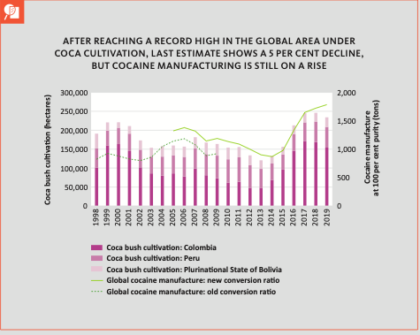  The Protocol Against the Illicit Manufacturing of and Trafficking in Firearms, Their Parts and Components and Ammunition was adopted. | 31 May 2001
The United Nations Global Initiative to Fight Human Trafficking was launched. | 26 March 2007
The Convention on International Trade in Endangered Species of Wild Flora and Fauna (CITES) was adopted. | 3 March 1973

Previous attempts to resolve the issue
The United Nations Convention against Transnational Organized Crime (The Palermo Convention)
The United Nations Convention against Transnational Organized Crime, also known as the Palermo Convention, was adopted by General Assembly resolution 55/25 of 15 November 2000. Opening for signature by Member States at a High-level Political Conference convened for that purpose in Palermo, Italy, on 12-15 December 2000, it entered into force on 29 September 2003. The Convention is further supplemented by three Protocols, which target specific areas and manifestations of organized crime that will be further viewed in the report.
The Convention bears significance as the representation of a major step towards the fight against the crimes mentioned, signifies the recognition of the seriousness of the problems and the need to foster and enhance close international cooperation in order to tackle the issues. States that ratify this instrument commit themselves to taking a series of measures against transnational organized crime including the creation of domestic criminal offenses, the adoption of new and sweeping frameworks for extradition, mutual legal assistance, law enforcement cooperation, the promotion of training, and technical assistance for building or upgrading the necessary capacity of national authorities.
The Protocol to Prevent, Suppress and Punish Trafficking in Persons, especially Women and Children
The Protocol to Prevent, Suppress and Punish Trafficking in Persons, especially Women and Children was adopted by General Assembly resolution 55/25, entering into force on 25 December 2003. It is the first global legally binding instrument with an agreed definition on trafficking in persons, with the intention to facilitate convergence in national approaches so as to establish domestic criminal offenses that would support efficient international cooperation in investigating and prosecuting trafficking in persons cases and additionally, to protect and assist the victims of trafficking in persons with full respect for their human rights.
The Protocol against the Illicit Manufacturing of and Trafficking in Firearms, their Parts and Components and Ammunition
The Protocol against the Illicit Manufacturing of and Trafficking in Firearms, their Parts and Components and Ammunition was adopted by General Assembly resolution 55/255 of 31 May 2001. It entered into force on 3 July 2005. As the first legally binding instrument on small arms at the global level, this Protocol aims to promote, facilitate and strengthen cooperation among Member States in order to prevent, combat and eradicate the illicit firearms producing and trading. The ratification of this Protocol commits States to adopt a series of crime-control measures and implement in their domestic legal order three sets of normative provisions, the first one relating to establishment of criminal offenses, the second to a system of government authorizations or licensing, the third to the marking and tracing of firearms.
The United Nations Global Initiative to Fight Human Trafficking (UN.GIFT)
The United Nations Global Initiative to Fight Human Trafficking (UN.GIFT) was conceived to promote the global fight on human trafficking, on the basis of international agreements reached at the UN, launched on 26 March 2007. The objective is to promote initiatives aimed at grasping the local government, civil society and companies so as to attempt an adequate address of human trafficking issues, which also involves recruiting and transportation for sexual exploitation or slavery.
The Convention on International Trade in Endangered Species of Wild Flora and Fauna (CITES)
The Convention on International Trade in Endangered Species of Wild Flora and Fauna (CITES) is an international agreement between governments with an objective to ensure that international trade in specimens of wild animals and plants does not threaten the survival of the species, adopted in 3 March 1973 and entered into force on 1 January 1975.
Possible Solutions
- Emphasis on education and awareness of society, especially on the illicit drug trading and usage with the objective of combating misinformation
- Inclusion, support and empowerment of communities, civil society organizations and networks of people related to prevention of drug usage, healthcare and any aspects of service
- Forensics level assistance regarding the ultimate support of both domestic and international criminal investigations into drug trafficking
- Resolving the deficiency of proper intelligence methods by promoting substantial improvement on surveillance and targeting capacity with regard to maritime, land, rail and air cargo
- Monitoring and assistance for manufacturers of licit drugs and pharmaceuticals in order to reduce illicit cultivation and production

Appendix/Appendices
- tedimun.org

Bibliography
- Counterfeit goods: a bargain or a costly mistake? (n.d.). Transnational Organized Crime: Let’s Put Them Out of Business. https://www.unodc.org/toc/en/crimes/counterfeit-goods.html
- Cybercrime. (n.d.). https://www.unodc.org/e4j/en/tertiary/cybercrime.html
- Environmental crime: trafficking in wildlife and timber. (n.d.). Transnational Organized Crime: Let’s Put Them Out of Business. https://www.unodc.org/toc/en/crimes/environmental-crime.html
- Global Firearms Programme. (n.d.). United Nations: Office on Drugs and Crime. https://www.unodc.org/unodc/en/firearms-protocol/
- Human Trafficking. United Nations: Office on Drugs and Crime. https://www.unodc.org/unodc/en/human-Trafficking/Human-Trafficking.html
- International Monetary Fund: About. (n.d.). IMF. https://www.imf.org/en/About
- MUN Cybercrime. (n.d.). https://www.unodc.org/e4j/en/mun/crime-prevention/cybercrime.html
- Migrant Smuggling. (n.d.). United Nations: Office on Drugs and Crime. https://www.unodc.org/unodc/en/human-trafficking/migrant-smuggling/migrant-smuggling.html
- Organized Crime Module 3 Key Issues: Counterfeit Products Trafficking. (n.d.). https://www.unodc.org/e4j/zh/organized-crime/module-3/key-issues/counterfeit-products-trafficking.html
- The Financial Action Task Force | FinCEN.gov. (n.d.). https://www.fincen.gov/resources/international/financial-action-task-force
- Transnational Organized Crime: A Growing Threat to National and International Security. (n.d.). The White House. https://obamawhitehouse.archives.gov/administration/eop/nsc/transnational-crime/threat
- Transnational organized crime: the globalized illegal economy. (n.d.). Transnational Organized Crime: Let’s Put Them Out of Business. https://www.unodc.org/toc/en/crimes/organized-crime.html
- United Nations Office on Drugs and Crime. (n.d.). The Globalization of Crime: A Transnational Organized Crime Threat Assessment. https://www.unodc.org/documents/data-and-analysis/tocta/TOCTA_Report_2010_low_res.pdf
- United Nations Office on Drugs and Crime. (n.d.-a). Estimating Illicit Financial Flows Resulting From Drug Trafficking and Other Transnational Organized Crimes. https://www.unodc.org/documents/data-and-analysis/Studies/Illicit_financial_flows_2011_web.pdf
- United Nations Office on Drugs and Crime. (n.d.-b). Global Study on Firearms Trafficking 2020. https://www.unodc.org/documents/data-and-analysis/Firearms/2020_REPORT_Global_Study_on_Firearms_Trafficking_2020_web.pdf
- World Wildlife Crime Report 2020: Introduction. (n.d.). https://www.unodc.org/documents/data-and-analysis/wildlife/2020/WWLC20_Chapter_1_Introduction.pdf
- What is INTERPOL? (n.d.). https://www.interpol.int/Who-we-are/What-is-INTERPOL
- What We Do. (n.d.). World Bank. https://www.worldbank.org/en/what-we-do

