TED ISTANBUL MODEL UNITED NATIONS 2023
“Shifting Tides: Striving for Change in the Modern World”
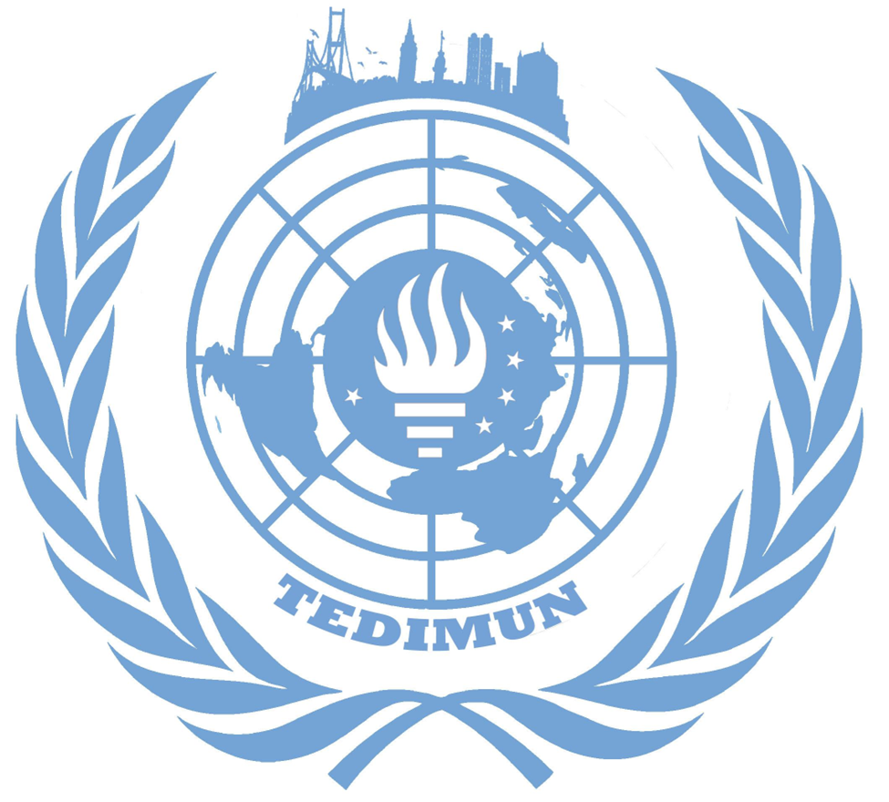
The issue of protecting native tribes within the Amazon rainforest
Büşra Koyuncu - Kerem Güngör
Deputy Chairs
Committee: GA3 - Social and Humanitarian Committee
Issue: The issue of protecting the native tribes within the Amazon Rainforest
Student Officer: Büşra Koyuncu - Deputy Chair, Kerem Güngör - Deputy Chair
Introduction
The question of indigenous people from the viewpoint of the civilised world has been a matter of debate ever since the advent of civilisation itself. But the matter has been most perpetuated by the age of discovery: Many tribes have been subject to violence, genocide, slavery and plague, all in name the name of exploration and colonisation.
Presently, though under protection by the states they inhabit to an extent, it is not a stretch to say that the indigenous peoples face great issues. Some of these issues such as forceful relocation and fights for cultural survival are politically-motivated; while others stem from the rapidly-growing civilisation that they find themselves so close to, which pose many humanitarian issues, such as those caused by deforestation and the like.
The rights of indigenous peoples have been subject to many discussions in the UN, culminating into the UN Declaration on the Rights of Indigenous peoples. It is apparent, however, that no one declaration is sufficient to eradicate the problems hitherto mentioned.In a civilised world, haunted by poor access to basic services such as education and health, high levels of poverty, disproportionate suffering from climate change and environmental degradation, the indigenous people find themselves left behind. While many rights exist on paper, the reality is a very small number of countries adhere to them.
The aim of this committee may be viewed as trying to find the answer to the question “How do we save others from ourselves?” “And how do we do it with regards to international cooperation and diplomacy?” In preparing for this committee and during the course of research, these may be some important questions to keep in mind.

Definition of Key Terms
Indigenous Peoples: Communities that are self-proclaimed as indigenous peoples are indigenous people. Though a broader definition would include that they are communities which have been inhabiting ancestral territories since time immemorial, and that they share different cultural identities, with unique economic, cultural, and political institutions separate from that of a modern state.
Uncontacted Peoples: Communities of indigenous peoples living without constant contact with the world community. Numbering up to 100 tribes to a total of 10000 people, most of these tribes have not had any contact with the outside world.
The right to self-determination: The belief that peoples, based on respect for the principle of equal rights and fair equality of opportunity, have the right to freely choose their sovereignty and international political status with no interference. (UN Charter, Article 1)
Ancestral Lands/Domain: Area generally belonging to an indigenous people that have been passed onto them from their ancestors, since time immemorial.
Garimpeiros: Small-scale mining illegal mining operations for gold and other valuable resources within the Amazon, generally referring to those from Brazil.
General Overview
The Amazon is home to more than 30 million people. these people belong to some 350 different ethnic groups, subdivided further into 9 different political systems. There are 3344 formally recognised indigenous territories, 60 of which remaining largely isolated. (Uncontacted peoples). On paper, all of these territories are self-governing, with no interference from the host state. They do, however still face many issues, some of which are outlined below:
Garimpeiros
Whilst most valuable metals such as gold are mined by corporations, there are millions of people across the globe who are working independently and illegally in smaller-scaled operations, particularly to escape poverty.
While not all mal-aligned, the consequences of the actions of garimpeiros range from mild to extinction-threatening, according to local tribes. For instance, the Yanomami tribe believe that they face great risks involving losing their lands, culture and their traditional way of life due to garimpeiros. The rich gold and minerals which lay under their lands has made many illegal mining operations rampant, which have gone insofar as cutting down great parts of forests, poisoning rivers and bringing deadly diseases to both animals and members of the tribe.
Aside from these, illegal hunting similar to those done by garimpeiros disrupt the ecosystem within the borders of the tribe, leading to malnutrition and health problems ad infinitum.
Perhaps the most dire consequence of their presence in the Amazon, however, is their contact with uncontacted tribes. By the laws of many countries covering the Amazon, most have very strict laws about first contact with such tribes. SOme only having had only the slightest
Forceful Relocation
Bordering on genocide, forceful relocation of tribes have regrettably been commonplace in even the 20th and 21st centuries. The competition of particularly mining and drilling companies for Amazon’s rich resources has been the main perpetuator for this. Though the Amazon is a supranational reserve and most drilling is prohibited except under specific circumstances, many governments in the region have been unable to enforce these laws, either by ineptitude or by unwillingness. Many loopholes have been found in the search for resources, and likewise, many more have been utilised to drive tribes out of their ancestral lands in order to facilitate the exploitation of the newly-found resources. No comprehensive study has been able to put a number into those affected by such relocations, and this is not helped by most governments’ secrecy in dealing with matters such as this.
“Without our land, we don't exist, and without land, there is no biodiversity, rivers, or animals. We, indigenous people, cannot survive without land. There is no harmony, no health, and there is no knowledge or movement of planet earth.” proclaims the leader of one tribe, empathising the importance of their ancestral lands. (“In The Amazon Rainforest, an Indigenous Tribe Fights for Survival.” OHCHR, )

Environmental Degradation - Climate Change
Pollution, deforestation, infrastructure projects and mass agriculture within the Amazon has been the catalyst for many derailments of the ecosystem, which directly affect the Indigenous Peoples. Outside influence of climate change should not be overlooked either. Many tribes live in constant harmony with the ecosystem in which they inhabit, thus the slightest derailment, such as those caused by the outside world, is cause for great concern.
For example, illegal mining and drilling changes draining patterns which disrupt the self-regenerative state of the forest. This destroys the habitat for indigenous species and thus leaving the Indigenous People to face problems finding food, or being dependent on imported, less nutritious food, both of which are detrimental to their traditional way of life. In case of excessive disruptions, the tribes may also be forced to leave their ancestral lands, and relocate.
Poor Access to Social Services
Many members of tribes face disproportionate issues with respect to their identity when faced with access to social services.
In education, for instance, indigenous children face great obstacles. First, many indigenous children do not have access to adequate schools. Where they do, many of the curricula have the goal of injecting one with a sense of national identity, culture and values. And it is not rare that this understanding of education be completely contradictory to that of their own values and culture. Children may find themselves either lost in no-man’s-land in terms of culture, or be completely disjointed from either their national or native identity. They may also face great difficulties if they are not speakers of the main language of instruction, which is more often than not the case. Regrettably, discriminatory remarks and bullying are also commonplace. In light of this, the education gap between indigenous peoples and the rest of the population keeps increasing.
The difference in life expectancy between indigenous populations can range from 8 to 20 years. Which may be to say, they face likewise issues with regards to accessing health services. Tuberculosis, for instance, is an illness that primarily affects people living in poverty, and it is widespread in many indigenous tribes. Cultural, linguistic and economic barriers prohibit dealing with it. Malaria and malnutrition are other examples. Modern health systems may be sometimes viewed as incompatible by traditional tribes. As such, cooperation between modern and traditional is imperative.
Uncontacted Peoples
Aside from tribes which have legal recognition and live in constant contact with the outside world, there are also peoples who have either had no contact, or have had only very little contact with the outside world. As such, these tribes are subject to great menaces. Moreover, the amazon houses nearly 50% of the uncontacted peoples.
First, as most have not had any contact with the outside world, any incompetent first contacts are not only sure to be viewed as hostile, but may also change the way in which their society is to view any other contact for a prolonged period of time; as well as change their culture to be aggressive as such.
Second, due to the nature of their situation, they have never had any contact with diseases such as malaria and other diseases against which we have antibodies and vaccines, whereas they don’t. They may face devastating effects with any contact, leading to While this is a problem for many tribes, contacted or not, uncontacted peoples are especially vulnerable.
Major Parties Involved
Brazil

The majority of the Amazon,%60, is located within Brazil which makes Brazil in control of the rainforests and the tribes living in the Amazon. Before 2019 the Amazon forests were protected since they were seen as the “lungs of the world”. However, after the new president, Jair Bolsonaro, the situation in the Amazon rainforest started going worse since the new president is not actively protecting the forests. The forests are being destroyed mostly by illegal miners. 1.2 million hectares of Amazon are deforested by mining activities.

These mining activities are also ruining the native tribes’ health since the people living there have no immunity to the bacteria these miners are bringing to their communities. One example of these bacterias are Covid-19. Covid-19 is brought by the miners and a few Covid-19-related deaths have been reported. The usage of mercury in the process of amalgamation of gold is also causing some health problems to the people living close to the mining spots such as mercury poisoning.

Yanomami

The Yanomami are the largest relatively isolated tribe in South America. They are located in the Amazon rainforests. It has been reported that the territory is one of the most attacked indigenous areas in Brazil by illegal miners. The attacks include rape, killings, attacks, and many more horrific cases of abuse like these. Amalgamation of gold which is using mercury to remove gold from the rock as an amalgam. The used mercury is being thrown into the rivers which are causing cataclysmic pollution in the rivers. The mercury is also stored in the bodies of the fish that live in that river. When the people living there eat these fishes the mercury passes onto the human body. This causes the amount of mercury in the human body to become seriously unhealthy.

Yanomami territory is hosting more than 20.000 illegal miners even though being a nationally protected area where mining is completely banned. The number is unnervingly increasing every day so the problems are also increasing swiftly. The leaders of the territory are expressing their concerns and anger by saying “Our land is again being invaded. Our rivers are again being polluted by mercury” and “The number of invaders has increased, both loggers and miners, who are at the service of people who have strong economic power, and organized crime is beginning to enter the territory. The environmental and health issue is getting worse and is putting the indigenous people at risk of extinction,” (“In the Amazon rainforest, an indigenous tribe fights for survival”)

The number of illnesses is also increasing as has been mentioned before. One of these illnesses is malaria. Malaria is a disease caused by a parasite mostly carried by mosquitoes. The pits made by miners create ideal conditions for these mosquitoes. Malaria causes a high fever and flu-like illness. Malaria can easily lead to death. Therefore the miners are not only causing deforestation but also the deaths of the native tribes.

APIB

The Articulation of Indigenous Peoples of Brazil is the national reference of Brazil’s indigenous movement. (“APIB”) They serve the purpose of strengthening the unity of indigenous people and unifying the problems indigenous people are going through. With the help of APIB, the file of the violation to tribes in Amazon has been taken to the International Criminal Court in the Hague. A complaint accusing Bolsonaro, the president of Brazil, of violating human rights has been filed. They also stand by the idea that this violation is opening a path for genocide on indigenous groups living in the area.

Timeline of Key Events

1690s | The colonists, aiming to capture indigenous people for slavery, discovered gold in the area. The Brazilian Gold Rush started.
1693 | Slaves have been relocated to Amazon to mine gold
1992 | The government granted the Yanomami 94.000 square kilometers of protected territory which showed the people if the government wants to remove illegal miners from the land, it can.
2019 | Jair Bolsonaro came into power.
August 9, 2021 | The APIB filed a statement at the International Criminal Court to denounce the Bolsonaro government.

Previous Attempts to Resolve the Issue

The issue of violation of human rights in Amazon has been a big problem for centuries. Organizations, governments, and people have tried to solve the issue by using lots of different methods.

A petition made by the natives living in the mining areas was one of the attempts to solve the issue. The petition Miners Out Covid out aimed to remove miners that are spreading Covid-19 to the native tribes living in the area. In the website created to gather signatures the people of Yanomami expressed their concern with the words “We, the Yanomami, do not want to die. Help us expel more than 20,000 miners who are spreading Covid-19 throughout our lands.” The campaign is supported by APIB. The petition is still ongoing but is not so effective in the path of removing the miners from the area.

Another attempt was locating military bases to combat illegal mining in the hotspots of mining. The purpose was to remove miners mostly from the areas most affected by the act of illegal mining such as La Pampa. However, this attempt also was not so functional.

Possible Solutions

The violation of human rights in the lands of the Amazon rainforest is caused by a lot of different causes branching from one big problem: Illegal mining. There have been lots of attempts to fix this issue as mentioned. However, the problem is still a big threat to both the tribes living there and the trees that are named the “lungs of the world”. Therefore this problem should be fixed before causing bigger, irreversible results.

One of the possible solutions is to improve an attempt: Sending an army to the illegal mining spots. This solution can work if it can be applied effectively. Therefore the army that the government will be sending there should first be trained about the tribes living there. They should learn how to have a healthy, both physically and mentally, relationship with them. This army should also be qualified enough to keep the illegal miners out of the area.

Another solution can be turning unprotected areas into protected areas and strengthening the protected areas. It is a fact that unprotected areas are violated more than protected areas. Therefore if these areas can be protected, fewer people, animals, and flora will be in danger.

Appendix/Appendices
United Nations Declaration on the Rights of Indigenous Peoples
https://www.ohchr.org/en/stories/2022/08/amazon-rainforest-indigenous-tribe-fights-survival
https://www.nationalgeographic.com/science/article/131222-amazon-kayapo-indigenous-tribes-deforestation-environment-climate-rain-forest
https://dialogochino.net/en/uncategorised/58783-mining-amazon-history-of-hope-and-conflict/

Bibliography
“Oil And Gas Extraction in the Amazon.” WWF, wwf.panda.org/discover/knowledge_hub/where_we_work/amazon/amazon_threats/other_threats/oil_and_gas_extraction_amazon. Accessed 30 December 2022.
Holmes, Bob. “How many uncontacted tribes are left in the world?” New Scientist, 22 August 2013, www.newscientist.com/article/dn24090-how-many-uncontacted-tribes-are-left-in-the-world. Accessed 30 December 2022.
“In the Amazon rainforest, an indigenous tribe fights for survival.” OHCHR, 9 August 2022, www.ohchr.org/en/stories/2022/08/amazon-rainforest-indigenous-tribe-fights-survival. Accessed 30 December 2022.
Momani, Abbas. “Indigenous Peoples.” Amnesty International, www.amnesty.org/en/what-we-do/indigenous-peoples. Accessed 30 December 2022.
Türk, Volker. “OHCHR and indigenous peoples.” OHCHR, www.ohchr.org/en/indigenous-peoples. Accessed 30 December 2022.
“UN Agencies Collaborate on Amazon Conservation Efforts.” Cultural Survival, 20 July 2005, www.culturalsurvival.org/news/un-agencies-collaborate-amazon-conservation-efforts. Accessed 30 December 2022.
“Mandated Areas | United Nations For Indigenous Peoples.” the United Nations, https://www.un.org/development/desa/indigenouspeoples/mandated-areas1.html. Accessed 30 December 2022.
Betim, Felipe. “Mining in the Amazon: a history of hope and conflict.” Diálogo Chino, 26 September 2022, https://dialogochino.net/en/uncategorised/58783-mining-amazon-history-of-hope-and-conflict/. Accessed 30 December 2022.
Brown, Kimberley, and Genevieve Belmaker. “Illegal mining in the Amazon 'not comparable to any other period of its history.'” Mongabay, 20 December 2018, https://news.mongabay.com/2018/12/illegal-mining-in-the-amazon-not-comparable-to-any-other-period-of-its-history/. Accessed 30 December 2022.
Cereceda, Rafael. “Peru installs military bases to protect the Amazon from ill.” Euronews, 7 March 2019, https://www.euronews.com/2019/03/07/peru-installs-military-bases-to-protect-the-amazon-from-illegal-mining. Accessed 30 December 2022.
“Crisis in the Brazilian Amazon.” Human Rights Watch, 19 April 2022, https://www.hrw.org/news/2022/04/19/crisis-brazilian-amazon. Accessed 30 December 2022.
“Illegal mining, abuses surge on Indigenous land in Brazil: Report.” Al Jazeera, 11 April 2022, https://www.aljazeera.com/news/2022/4/11/illegal-mining-abuses-surge-on-indigenous-land-in-brazil-report. Accessed 30 December 2022.
“In the Amazon rainforest, an indigenous tribe fights for survival.” OHCHR, 9 August 2022, https://www.ohchr.org/en/stories/2022/08/amazon-rainforest-indigenous-tribe-fights-survival. Accessed 30 December 2022.
Jones, Benji. “What Jair Bolsonaro did to the Amazon rainforest, in 2 charts.” Vox, 3 October 2022, https://www.vox.com/down-to-earth/2022/9/29/23373427/amazon-rainforest-brazil-jair-bolsonaro-lula-deforestation. Accessed 30 December 2022.
Watson, Katy. “Jair Bolsonaro: The Amazon and why world is watching Brazil's election.” BBC, 21 October 2022, https://www.bbc.com/news/world-latin-america-63313990. Accessed 30 December 2022.
Zimmerman, Barbara. “Rain Forest Warriors: How Indigenous Tribes Protect the Amazon.” National Geographic, 23 December 2013, https://www.nationalgeographic.com/science/article/131222-amazon-kayapo-indigenous-tribes-deforestation-environment-climate-rain-forest. Accessed 30 December 2022.
“APIB.” APIB, https://apiboficial.org/apib/?lang=en. Accessed 30 December 2022.
Betim, Felipe. “Mining in the Amazon: a history of hope and conflict.” Diálogo Chino, 26 September 2022, https://dialogochino.net/en/uncategorised/58783-mining-amazon-history-of-hope-and-conflict/. Accessed 30 December 2022.
Brown, Kimberley, and Genevieve Belmaker. “Illegal mining in the Amazon 'not comparable to any other period of its history.'” Mongabay, 20 December 2018, https://news.mongabay.com/2018/12/illegal-mining-in-the-amazon-not-comparable-to-any-other-period-of-its-history/. Accessed 30 December 2022.
Cereceda, Rafael. “Peru installs military bases to protect the Amazon from ill.” Euronews, 7 March 2019, https://www.euronews.com/2019/03/07/peru-installs-military-bases-to-protect-the-amazon-from-illegal-mining. Accessed 30 December 2022.
“Crisis in the Brazilian Amazon.” Human Rights Watch, 19 April 2022, https://www.hrw.org/news/2022/04/19/crisis-brazilian-amazon. Accessed 30 December 2022.
“Illegal mining, abuses surge on Indigenous land in Brazil: Report.” Al Jazeera, 11 April 2022, https://www.aljazeera.com/news/2022/4/11/illegal-mining-abuses-surge-on-indigenous-land-in-brazil-report. Accessed 30 December 2022.
“In the Amazon rainforest, an indigenous tribe fights for survival.” OHCHR, 9 August 2022, https://www.ohchr.org/en/stories/2022/08/amazon-rainforest-indigenous-tribe-fights-survival. Accessed 30 December 2022.
Jones, Benji. “What Jair Bolsonaro did to the Amazon rainforest, in 2 charts.” Vox, 3 October 2022, https://www.vox.com/down-to-earth/2022/9/29/23373427/amazon-rainforest-brazil-jair-bolsonaro-lula-deforestation. Accessed 30 December 2022.
Watson, Katy. “Jair Bolsonaro: The Amazon and why world is watching Brazil's election.” BBC, 21 October 2022, https://www.bbc.com/news/world-latin-america-63313990. Accessed 30 December 2022.
Zimmerman, Barbara. “Rain Forest Warriors: How Indigenous Tribes Protect the Amazon.” National Geographic, 23 December 2013, https://www.nationalgeographic.com/science/article/131222-amazon-kayapo-indigenous-tribes-deforestation-environment-climate-rain-forest. Accessed 30 December 2022.

The UN does not have a singularly authoritative definition for neither people, nor indigenous people. The right to identify as such rests, according to the Charter, on the people themselves. See: The right to self-determination

