TED ISTANBUL MODEL UNITED NATIONS 2023

"Shifting Tides: Striving for Change

in the Modern World"

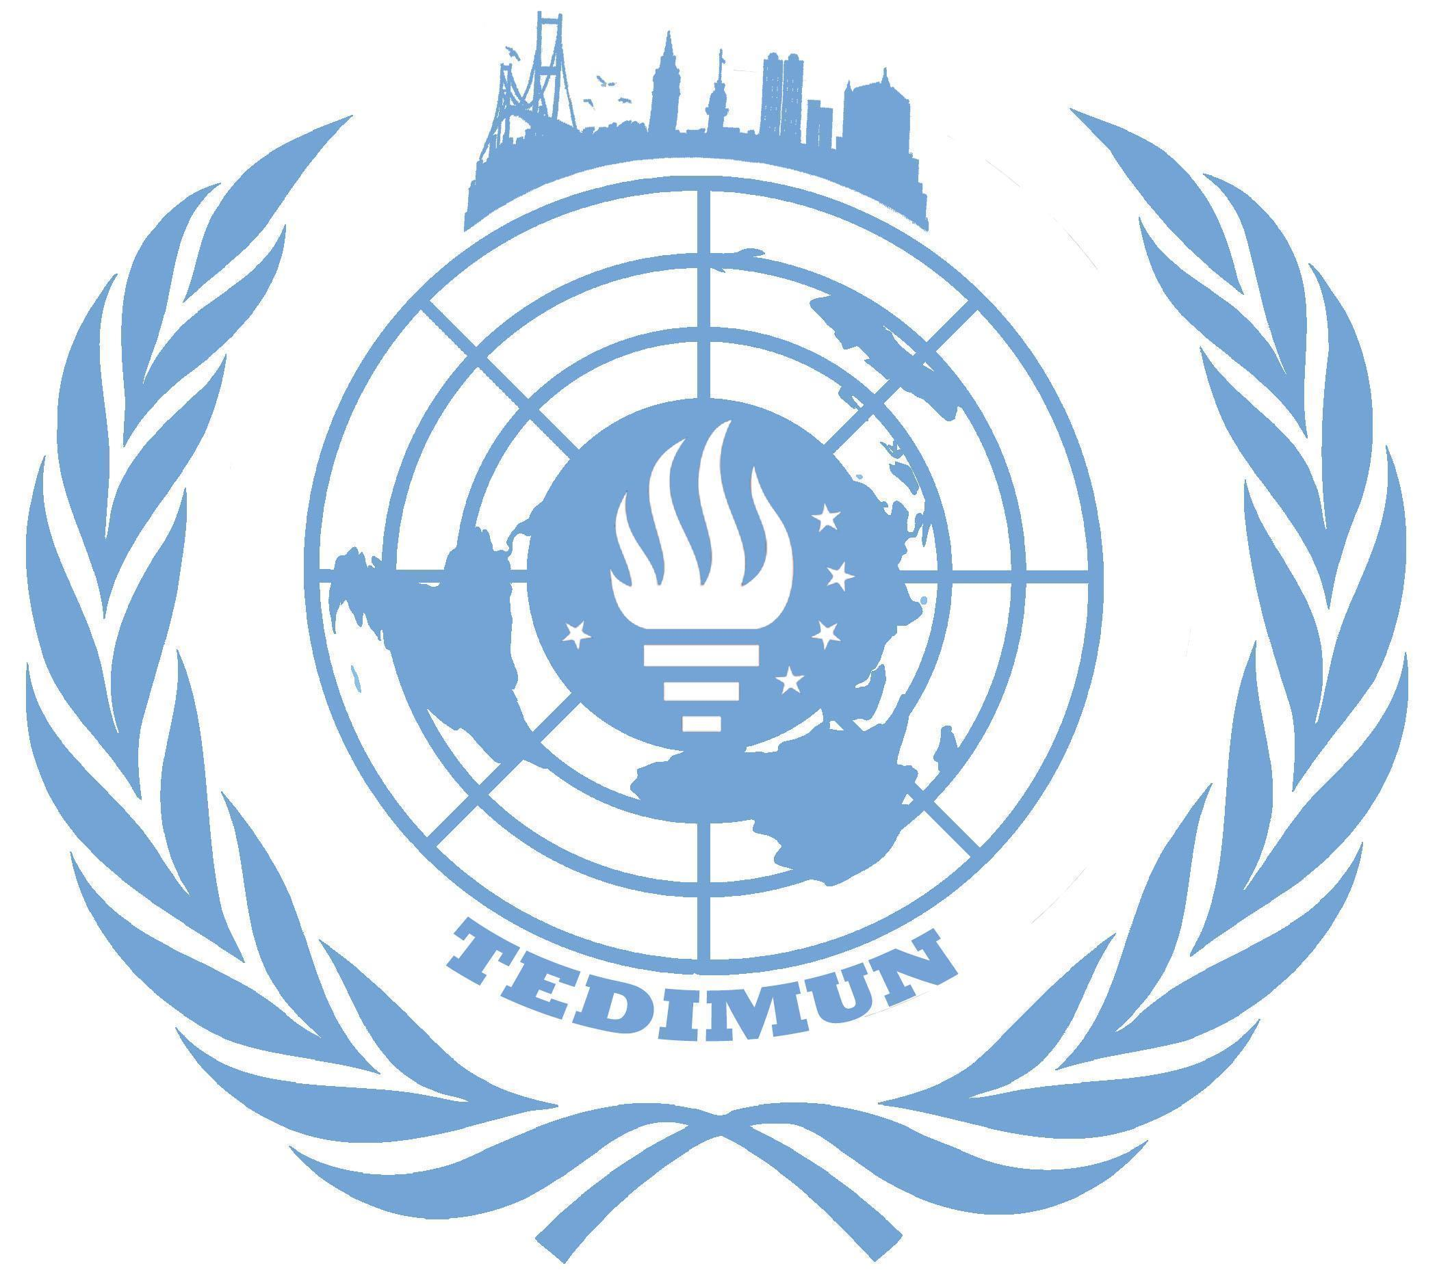
The issue of prevention of global microplastic pollution

Ada Han Yeşil
President Chair

Committee: GA4-Environmental Committee
Issue: The issue of prevention of global microplastic pollution
Student Officer: Ada Han Yeşil (President Chair)

Introduction
Plastic waste has become one of the most threatening problems for our environment. During the 1960s, the first cases of plastic debris were noticed in the ocean; however, scientists have only become aware of the severity of the issue in recent years. Plastic debris is examined under two main categories: Microplastics and Macroplastics. Microplastics are the smaller grains of plastic, which are more dispersive. Although plastic pollution is more visible in urban areas, findings of microplastic waste are mostly seen in remote environments, such as polar seas. Plastic consists of deleterious chemicals, such as bisphenol A (BPA), and it takes between 20 and 500 years for plastic to decompose in nature. Due to their high dispersivity, microplastics are very prone to interact with the food chain, and thus, they are frequently ingested by other living organisms, especially by marine animals as microplastics are mostly seen in the ocean. In the 1980s, the United Nations took a big step against pollution in general with the Basel Convention, whose aim was to reduce ‘hazardous wastes’. However, some member states didn’t put the convention into force even if they signed or accepted it. As such, the convention was not efficient enough to scale down the pollution, and the issue persisted while increasing in severity. When this situation became a topic in the media, major corporations started to run eco-friendly projects in order to raise awareness against the usage of plastics. Despite this, plastic production and mismanagement is still rising. However, during the Covid-19 pandemic, reports found that plastic consumption had decreased by 2.2%, despite the rise in the usage of plastic packaging during the lockdowns. Lastly, it is important to keep in mind that only 9% of the plastic on Earth is being recycled, while the rest is being mismanaged.

Definition of Key Terms
Microplastic: Particles of plastic which are smaller than 5 mm in length. Microplastics cause pollution in natural ecosystems. They can be originated from a variety of sources such as cosmetics, clothing, food packaging and industrial processes.
Dispersive: Something that is prone to spread over a large area. In this report, it is used to emphasize the diffusive characteristic of microplastics.
Remote Environment: Natural habitats that are far from settlements and human activities such as polar sea ice and deep sea sediments.
Deleterious Chemicals: Toxic chemical substances and components that are harmful for living organisms, such as mercury, lead, and cyanide. They can cause diseases or permanent damage in visceral organs. Plastics contain deleterious chemicals like BPA, PFAS, and phthalate.
Combustion: The process of burning carbonic substances with oxygen, which produces carbon dioxide (CO₂), water (H₂O), and heat.
Landfill: The name given to spots used for underground waste burial; a disposure method that causes soil and air pollution.

General Overview
Plastic pollution has been causing damage on Earth for decades. Some consider high consumption and mismanagement of waste to be the major contributing factors to plastic pollution. Currently, many governments and organizations are carrying out projects to prevent plastic pollution, such as the ‘Zero Waste Policy’. However, these measures are failing to lower the rates of plastic usage due to the lack of appropriate alternatives to plastic. Microplastics are in almost every product, including cosmetics, baby products, detergents and medicines. Therefore, plastic plays a big role in industry. Plastic usage rates were rising before the Covid-19 pandemic, but during the pandemic, plastic consumption saw a 2.2% decrease in OECD states. Despite the decrease in plastic consumption, plastic packaging and medical equipment usage saw a large increase. As a result, littering rates have also increased. As soon as the pandemic started to subside, plastic consumption rates resumed increasing. According to the World Bank, 2.1 tons of waste is being generated annually and 12% of this waste consists of plastic.
Main Reasons Behind The Microplastic Pollution
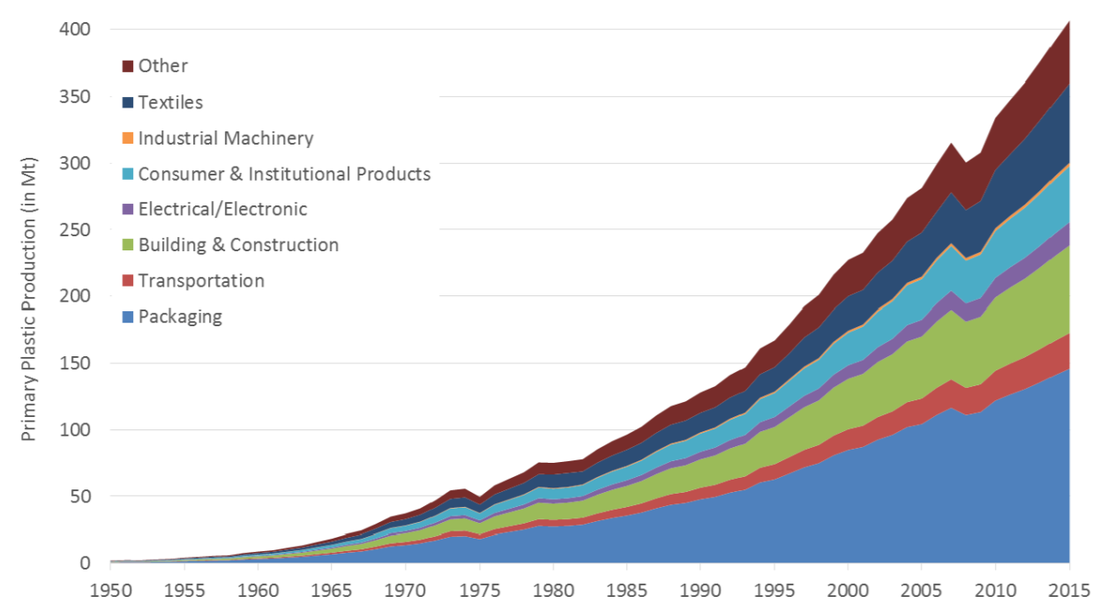
Microplastics are examined under two categories: Primary microplastics and secondary microplastics. Primary microplastics consist of these 4 main pollutants; synthetic textiles (35%), plastic pellets (15%), road marking paints (22%) and car tire junk (28%). With the natural activities, these microplastics are being scattered in nature through ways like the wind, storms, water runoff; especially to the oceans. Moreover, the mismanagement of the wastes as a whole is a crucial contributing factor to microplastic pollution. Harmful disposal methods such as littering, combustion and landfills are polluting the air, ground and the oceans.

The Historical Background Of The Situation
The invention of plastic was a revolutionary development for modern society and industry. People started to use plastic everywhere and this alteration brought the consequences with it. The first synthetic plastic was produced in 1907, (bakelite) and the first instance of microplastic debris was noticed in the ocean during the 1960s. When the situation became an urgent topic for the UN, member states prepared the Basel Convention which basically aimed to prevent general pollution. As soon as the situation showed up in the media, major companies like Starbucks or McDonald’s started carrying out eco-friendly projects.

Current Situation
Today, many member states have adopted the Zero Waste Policy, which was submitted by Türkiye to the UN. Furthermore, recycling rates are rising with the cooperation of governments and climate activists. However, recycling only represents 9% of waste management. 30% of primary microplastics and 75% of secondary microplastics are located in the oceans. According to the UN, there are an estimated 51 trillion particles of microplastic in the oceans. Also, the lack of recycling, city dust and irregular disposal of waste are further contributing to microplastic pollution.
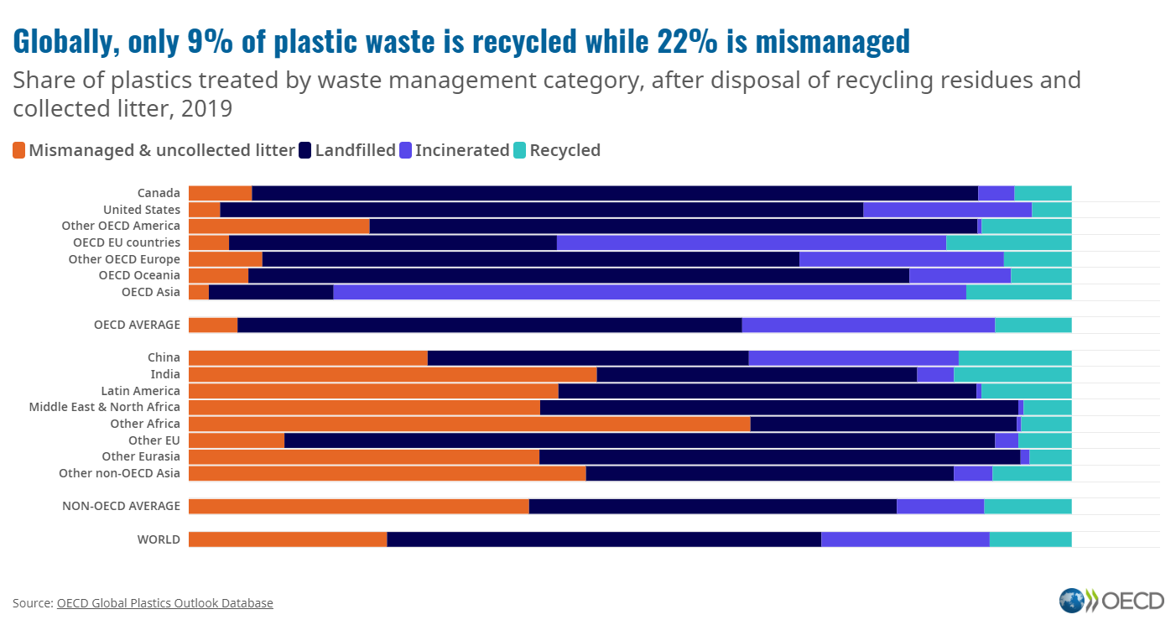

Major Parties Involved
China
The People’s Republic of China has prohibited the importation of recyclable plastics in 2018 in order to encourage exporters to review their recycling systems. 55% of Chinese plastic waste flows into the ocean from the Yangtze River. According to Scientific American, China contributes 30% of all plastic waste going to the ocean in the world.

The United States of America
In the US, some states have been working to reduce the damaging effects of microplastics, such as Illinois, who banned the production of cosmetics containing microplastics. In 2015, President Barack Obama signed the Microbead-Free Waters Act 2015 which bans ‘rinse-off’ cosmetic products. The act was put into force in 2017. In 2018, an amendment was entertained to combat marine pollution and save the seas.

Japan
In 2018, a bill was passed by the Japanese government which aims to reduce microplastic especially in marine environments. The bill intended to reduce hazardous personal care products and raise public awareness. However there are not any sanctions or penalties mentioned in the bill for the prohibited cosmetics manufacturers.

Timeline of Key Events
When | Event
1907 | The first synthetic plastic is produced.
1960s | The first microplastic debris was seen in the ocean.
22th March, 1989 | The Basel Convention on the Control of Transboundary Movements of Hazardous Wastes and their Disposal was adopted and entered into force.
25th December, 2015 | The Microbead-Free Waters Act 2015 was enacted after being signed by President Barack Obama.
2017 | A UN resolution by Tüürkiye, which also was presented along with 105 other countries, addresses the efforts for sustainable development through zero-waste initiatives launched by the Turkish first lady.
April, 2018 | The European Commission's Group of Chief Scientific Advisors commissioned a comprehensive review of the scientific evidence on microplastic pollution through the EU's Scientific Advice Mechanism.
24 July, 2018 | A microplastic reduction amendment was passed by the U.S. House of Representatives. The legislation, as part of the Save Our Seas Act designed to combat marine pollution, aims to support the NOAA's Marine Debris Program.
January, 2019 | In January 2019, the European Chemicals Agency (ECHA) proposed to restrict intentionally added microplastics.
December, 2022 | The UN General Assembly unanimously adopted a resolution Wednesday on a “zero-waste” initiative presented by Türkiye. The project has received international attention with UN Secretary-General Antonio Guterres expressing his gratitude to Türkiye’s first lady during a conference in New York.

Previous Attempts to Resolve the Issue
The Basel Convention on the Control of Transboundary Movements of Hazardous Wastes and their Disposal was signed by many member states which aims to reduce hazardous wastes and regulate the disposal procedure. However the convention still has not been put into force by many member states.

A resolution was passed in the United Nations Environment Assembly (UNEA) titled “End plastic pollution: Towards an international legally binding instrument” on 2 March 2022 regarding the topic. This resolution plans to reduce plastic waste and emissions and takes the principles of the Rio Declaration on Environment as a basis to combat the issue at hand. (UNEP,/EA.5/Res.14)
Compilation of United Nations Environment Assembly resolutions on
marine litter and microplastics was adopted by the UN which contains 4 different resolutions for the prevention of microplastics. These resolutions, adopted between 2014 and 2019, focus on the reduction of marine litter, debris and microplastics. (UNEP/EA.1/Res.6), (UNEP/EA.2/Res.11), (UNEP/EA.3/Res.7), (UNEP/EA.4/Res.6)

Possible Solutions
The chairboard strongly recommends delegates to propose initiatives to raise public awareness, especially in LEDC’s since they have less recycling and research centers. Furthermore, establishing more research centers and funding research on organic plastics will lower the chemical plastic usage and provide a more sustainable material for the industry. Also, it will be fruitful for the delegates to encourage every member state to put the Basel Convention in force. Moreover, establishing a commission in the UN to inspect the waste management and disposal procedures of the member states in order to have a reliable inspector worldwide.

Useful Links and Resources
- https://wedocs.unep.org/bitstream/handle/20.500.11822/39812/OEWG_PP_1_INF_1_UNEA%20resolution.pdf
- https://wedocs.unep.org/handle/20.500.11822/32238
- https://www.oecd.org/environment/plastic-pollution-is-growing-relentlessly-as-waste-management-and-recycling-fall-short.htm
- http://www.basel.int/Home/tabid/2202/Default.aspx

Bibliography
Alice A.HortonaPersonEnvelopeDavid K.A.Barnesb, et al. “Microplastic Pollution in a Rapidly Changing World: Implications for Remote and Vulnerable Marine Ecosystems.” Science of The Total Environment, Elsevier, 18 June 2020, https://www.sciencedirect.com/science/article/pii/S0048969720338717

Parker, Laura. “Plastic Pollution Facts and Information.” Environment, National Geographic, 3 May 2021, https://www.nationalgeographic.com/environment/article/plastic-pollution.

&64;CondorFerries. “100+ Plastic in the Ocean Statistics & Facts (2020-2021).” Condor Ferries, https://www.condorferries.co.uk/plastic-in-the-ocean-statistics#:~:text=More%20than%201%20million%20plastic,as%20waste%20in%20the%20ocean.

Ritchie, Hannah, and Max Roser. “Plastic Pollution.” Our World in Data, 1 Sept. 2018, https://ourworldindata.org/plastic-pollution

Islam, S. Nazrul, et al. “Global Primary Plastics Production According to Industrial Use Sector ...” Frontier Technology Quarterly, September 2019: Frontier Technologies for Addressing Plastic Pollution, Sept. 2019, https://www.researchgate.net/figure/Global-primary-plastics-production-according-to-industrial-use-sector-from-1950-to-2015_fig5_336073612

