TED ISTANBUL MODEL UNITED NATIONS 2023
“Shifting Tides: Striving for Change in the Modern World”
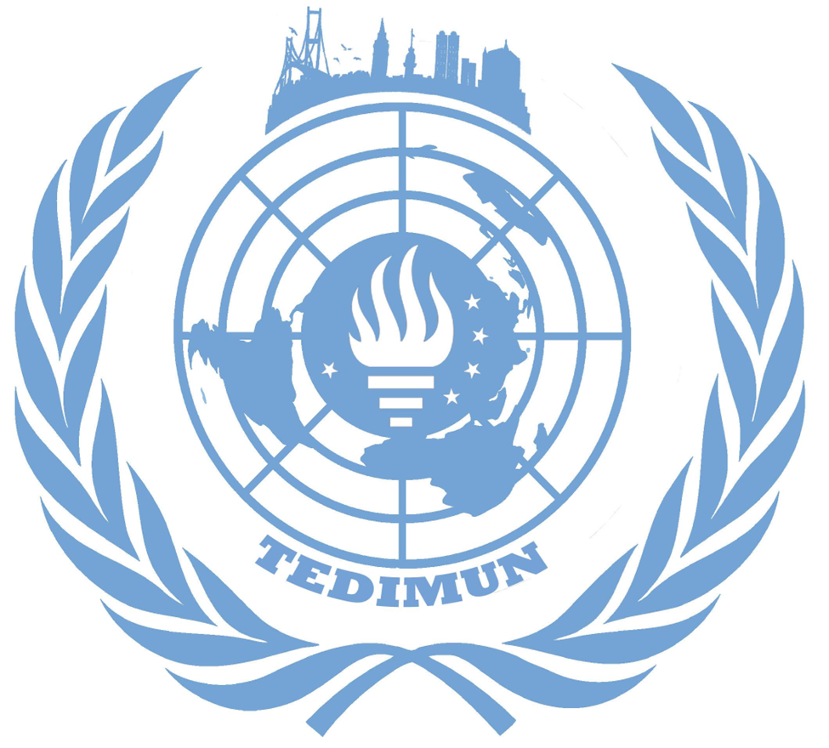

Preventing the financing and the trafficking of the illicit arms trade in West Africa
President Chair-Mert Özden
Deputy Chairs-Duru Öztürk, Yağmur Eda Yıldız
Committee: Disarmament Committee ( GA1)
Issue: Preventing the financing and the trafficking of the illicit arms trade in West Africa
Student Officer: Mert Özden-President Chair, Duru Öztürk-Deputy Chair
Introduction
The Assembly of the Union convened its Ordinary Session in January 2017. It endorsed the African Union's (AU) Master Roadmap of Practical Steps to Silence Guns in Africa by 2020. (AU Roadmap). The AU Roadmap includes a variety of practical measures and action modalities to address the fundamental causes of conflict, as well as the instruments and enablers of violence, including curbing illegal weapons transfers across the continent and to conflict zones. In order to provide more complete and up-to-date analysis to AU policy institutions and member states, the AU Commission collaborated with the Small Arms Survey on a regional mapping of illegal arms flows. The illicit arms trade is a major problem in West Africa, contributing to conflict, crime, and instability in the region. The trafficking of illegal weapons fuels violence and undermines efforts to promote peace and security. It is essential that we take action to prevent the financing and trafficking of these arms, in order to create a safer and more stable environment for all people in West Africa. In this essay, we will examine the issues surrounding the illicit arms trade in the region, and explore the measures that can be taken to combat it. By understanding the root causes of the problem and working together to implement effective solutions, we can make a real difference in the fight against the illegal arms trade in West Africa.
Definition of Key Terms
Illicit arms trafficking: Refers to the illegal trade of weapons, including firearms, explosives, and other military equipment. This type of trade typically involves the smuggling of weapons across national borders, often in violation of international laws and regulations. Illicit arms trafficking can also involve the illegal sale of weapons within a country, particularly if the transactions are not properly regulated or authorized. The illicit arms trade often fuels conflict and violence, and can undermine efforts to promote peace and stability in affected regions. It can also contribute to the proliferation of illegal weapons and the difficulty of controlling their spread.
Border Security: Border security refers to the measures taken by a country to protect its borders from unauthorized crossings and to prevent the illegal movement of people, weapons, drugs, and other contraband across the border. This can include physical barriers such as fences and walls, as well as patrols by law enforcement and military personnel. Border security can also involve the use of technology such as cameras, sensors, and drones to monitor border activity and detect potential threats. The goal of border security is to protect the sovereignty and integrity of a nation, and to prevent illegal activities such as smuggling, human trafficking, and terrorism from taking place.
Small Arms: Weapons defined for personal use, usually being one-handed, like pistols, or more with more complexity such as SMG’s (Sub-Machine Guns).
International Policing: The cooperation of nations to in order to fight international crime, such as drug or arms trafficking.
General Overview
This section will explain the nature of cross-border illicit fire-arm trafficking, identify causes for its widespread nature and lastly explore international policing as it relates to this situation.
The western African weapon and arms trafficking has far-reaching consequences that concern all nations. While arms are mostly produced in MEDC (More Economically Developed Countries) regions, they are transported to LEDC (Less Economically Developed Countries) through trafficking routes. The aim of international policing in this context is to prevent arms from crossing regions and expanding its reach. As such, the cross-border financial transactions that are being combatted refer to the international trafficking of arms.
To combat an issue at an continental scale, countries around the region have to combine their policing efforts and set up a network of intelligence. The criminal organizations and war-lords that trade in arms and weaponry almost always operate on an international scale, or are at least part of an international network. Given the situation, it becomes evident that the efforts of a single country alone would not be sufficient to take down a network of illicit arms trafficking. The fact that drug trafficking is so widespread indicates a continent's lack of border control. Arms are usually transported to other countries through routes which are either not supervised by governmental institutions, or routes under supervision where the authorities are corrupt and turn a blind eye to criminal activities.
Western African Illegal Arms Trade
Western african illegal arms trade began and rose during the 20th century, the decolonization process. The issue arose when many of the European countries formerly being responsible for the law and enforcement in the region, began when they started abandoning their posts and leaving. This paved path for cold-war era Soviet funding of the separatists and other extreme left factions within the newly formed countries, one of the most famous of the fundings being based on Soviet weaponry such as the Kalashnikov-47, which is a highly reliable, cheap and effective weapon to come-by during the era. When the western civilization, found out about the plots and plans of the Soviet Union in the region, U.S.A and many other western block nations decided to supply their own weaponry to the other factions, there are many other examples of this such as the Contras in Latin America, which was later dissolved and abandoned by the U.S after the Soviet Union dissolved. After the Cold War, there was a time when West Africa received tons of armaments from outside the continent. This era has largely passed, because today, regional supply can satisfy local demand. On the one hand, the number of civil wars in Africa has declined since the 1990s, reducing demand. On the other, the firearms trafficked during those years did not evaporate, and continue to be re-circulated throughout the region.(1)

Region-wide or otherwise known as Continental level policing can only be done if all the parties in the region decide to work cooperatively and find common-ground to eradicate the issue. This type of policing is done beyond the borders of only one country and usually is very similar to the EUROPOL. The extent to which this type of policing is permitted in a country should be so that a balance between state sovereignty and sufficient operational freedom is maintained.
(1)Firearms Trafficking in West Africa - United Nations Office on Drugs ... https://www.unodc.org/documents/toc/Reports/TOCTAWestAfrica/West_Africa_TOC_FIREARMS.pdf

Major Parties Involved
The United States Of America
The United States Of America has been a key player, from having very deep pockets to fund intercontinental and world-wide operations, to policing the world at a larger scale. United States, while having been one of the main causes of this issue, has been a key player at fighting and funding counter-terrorism operations in sub-saharan africa. The United States usually follow a protocol of its own individual organizations, they have proved very understanding and co-operative at border controls, internal affairs and gun-control of the region.
The United States has been involved in the prevention and countering of the illicit arms trafficking and war-lords trying to acquire weapons since the late 80s following Ronald Reagen’s strict policy of counteracting Soviet blocks. Reagen, went as far as to declare Soviet activity as a threat on the very-way of human life. Following these, American policies since the cold-war have improved as to being less paranoid and co-operative with intelligence matters.
United Nations
United Nations have been a key player in setting up and establishing summits, meets and more importantly coming up with a solution to the issue. United Nations though, having a bad record in Africa since the 90s has definitely improved its operations and has expanded the operations of UNODC, as well as being far more effective and heavy handed with PoA’s. This may be also within United States and British backing in the region, also not to mention LEDC’s (Less Economically Developed Countries), in the region has been trying to follow a more west-ward path in terms of democracy and leadership, after being a subject of failed Soviet diplomacy and funding.
West African Coast Initiative
West African Coast Initiative, though still young, as to being funded and established by the United Nations in 2009, has proven very effective within border control, providing regional security and policing the region very effectively as it workers co-operatively with EUROPOL, INTERPOL, UNODC, ECOWAS and UNOWA. This greatly makes this organization and initiative very effective as they share and co-operate within the intelligence helping catch hundreds and thousands of smugglers within the region since its establishment. The cooperation with ECOWAS has also helped stabilize and help the region prosper post-war lord occupations. (1)
(1)“West African Coast Initiative.” Https://Peacekeeping.un.org/Police/Initiatives/Waci.shtml.

Timeline of Key Events
Dates | Events That Happened
2001 | Adoption of PoA.
2003 | The issue of BMS1.
2005 | The adoption of ITI.
2006 | United Nations REVCON1.
2008 | BMS3, Illegalizing and enacting harsher policies for the distribution of Kalashnikov and other popular fire-arms within west african markets.
2010 | BMS4 Conference took place.
2011 | MGE1 Took place.
2012 | Revcon2 conference took place.
2014 | BMS5 Conference enacted harsher policies over the distribution.
2015 | MGE2 Conference took place.
2016 | BMS6 Conference, paved path for future REVCON4.
2018 | REVCON3 Conference occurred.
2021 | BMS7, And the latest biennial meeting.
2022 | REVCON4.

Previous attempts to resolve the issue
Previously, there have been many yet not sufficient attempts, but with many summits and the establishment of Coast Initiative the issue has been decreasing and the instability as well as the lack of border control in the region has been increasing significantly. The varying degrees of success talks for itself as the tons of funding of weaponry from the Western and Eastern block has finally managed to run-dry yet due to local smugglers and war-lords the local demand can be fulfilled by the local supply and logistics as the region still hasn’t got enough intelligence and police force nor the manpower to fight back, until now.
Various International as well as continental police and law-enforcement organizations have managed to help and aid the locals in solving this issue most commonly Coast Initiative, INTERPOL and UNODC being the main helping hands excluding the treasury provided by the United States.
Possible Solutions
The possible solution of this issue is controversial as United Nations still has many problems with holding summits, meets and even if such events occur, the region’s diversity causes many problems for the INTERPOL, UNODC and Coast Initiative as inter-continental police organizations require the legal consent and jurisdiction to be able to operate to full capability. One of the most controversial yet realistic solutions to this issue is to be able to come to an agreement and formulate jurisdictions and eliminate corruption within local police and border control agencies to be able to fight back against the supply-demand chain, eventually drying out their supplies.

Appendix/Appendices
https://www.tedimun.com/
Bibliography
Nicolas Florquin Head of Data & Analytics and Senior Researcher for the Small Arms Survey, and Alaa Tartir Senior Researcher and Coordinator of the Security Assessment in North Africa project at the Small Arms Survey. “Arms Trade to Africa Can Be Opaque.” The Conversation, 5 Nov. 2022, https://theconversation.com/arms-trade-to-africa-can-be-opaque-why-this-is-dangerous-175996.
“Arms Trafficking In Sub-Western Africa.” NextGen 5.0, NextGen 5.0, 1 Feb. 2022, https://www.nextgen50.org/post/small-arms-trafficking-in-west-africa.
Firearms Trafficking in West Africa - United Nations Office on Drugs ... https://www.unodc.org/documents/toc/Reports/TOCTAWestAfrica/West_Africa_TOC_FIREARMS.pdf
“West African Coast Initiative.” Https://Peacekeeping.un.org/Police/Initiatives/Waci.shtml.
Definition Of Key Terms. https://www.collinsdictionary.com/dictionary/english/border-security.

