TED ISTANBUL MODEL UNITED NATIONS 2023
“Shifting Tides: Striving for Change in the Modern World”
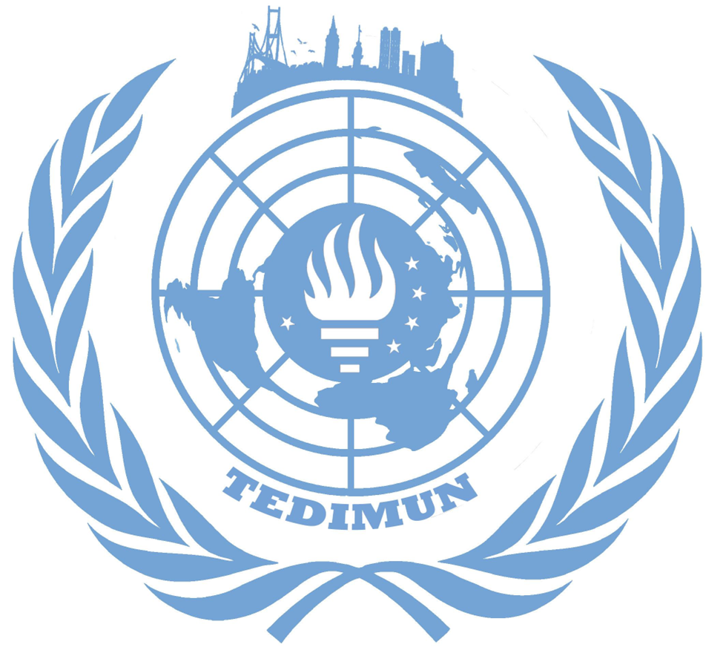Ensuring the human rights of the Palestinian people and other Arabs of the occupied territories
Menekşe Ezgi Akyol
President Chair
Committee: GA5-Legal Committee

Issue: Ensuring the human rights of the Palestinian people and other Arabs of the occupied territories

Student Officer: Menekşe Ezgi Akyol- President Chair

Introduction

The Palestine-Israeli conflict is a long lived Middle Eastern territory issue which first started in the 20th century and continued onto today. The situation was formed because the Israelis around the world, especially Europe, wanted a sovereign state of their own. The territory was British controlled and Arab lived. However, the Israelis stated that the territory was the most suitable for them. Other nations, which did not want anyone to interfere with their borders, encouraged them to take action.

The violation of human rights in the Palestinian-Israeli territory has been an issue since the first reclaim of the land by Israeli militants. But the situation has now turned into both Israeli and Palestinian citizens' fear of the other's escalation. The security of Palestinian citizens should be done by the cease of Israeli advancements in Palestinian region. The problem to both parties is a huge issue and hard to solve without the nations’ comprehension. Both nations' right to live in the area is opposeless. However, there are more aspects to take into consideration other than the Palestinian citizens. With the involvement of Afghanis, there are greater issues which should be debated.

Definition of Key Words

Six Day War: The major war of the conflict which ended in Israel’s favor and included Egypt, Syria and Transjordan.

Nakba: This is a phrase referring to Palestenians that are in grief for their homes and community, after immigrating to other states because of the conflict they used “Nakba” which is Arabic and translates to disaster for their loss of homeland .

Zionism: Zionists believe Judaism is a nationality as well as a religion. It is an ideology for Jewish people to become a whole and together believe that they deserve their ancestral homeland which also includes the region of Israel and so on.

General Overview

Besides the background of the past events that have occurred in the Israel-Palestine region, the first spark lit up with a participation plan from the UN in 1947. Later in 1948, when the state of Israel was proclaimed, five Arab countries; Egypt, Lebanon, Jordan, Syria, objected to the decision and went into a war with Israel. However, the conflict ended in the favor of Israel and as a result of that, the Israeli territory was divided into three parts: The West Bank, The Gaza Strip and The State of Israel. The world was aware of Israel by then and there were permanent agreements between nations. This led some Arab citizens to absquatulate from their community.
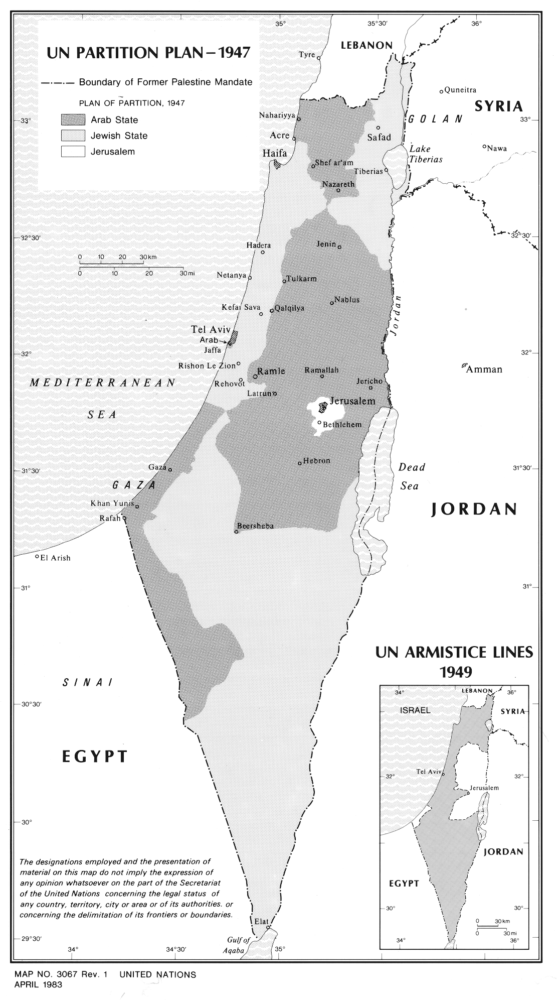

International law, such as the International Covenant on Civil and Political Rights and the International Covenant on Economic, Social, and Cultural Rights, protects the human rights of the Palestinian people and other Arabs living in the occupied territories, including the West Bank and Gaza Strip. These covenants outline the rights to which everyone is entitled, including the rights of life, liberty, and personal security; an adequate standard of living; access to education and employment; and the freedom to engage in culture and benefit from advances in science.

The Israeli government and military frequently violate the human rights of Palestinians and the other Arabs in the occupied territories. The use of excessive or lethal force against civilians, arbitrary detention and imprisonment, collective punishment, and the destruction of homes and other property are examples of these violations. As it involves the relocation of civilians into territory that has been occupied by military force, the construction of Israeli settlements in the occupied territories has also been determined to be a violation of international law. Human rights organizations and international bodies have documented numerous instances of human rights abuses in the occupied territories and have called on the Israeli government to respect the human rights of the Palestinian people and other Arabs living there.

The major event that changed the history of the conflict was the Six Day War which was an act upon many tensions that have already happened. The war started with a strike from Israel against Egypt and the major threat that Israel had toward Arab countries was diminished. To secure the peace they had, United Nations Security Council Resolution 242 was adopted in November 1967, but still it was not enough since some countries veered towards rejection. Palestine itself did not sign the resolution due to the lack of explicit reference to the Palestenians. The resolution was later signed by the Palestine Liberation Organisation in 1988.

Major Parties Involved

Egypt
In 1979, Israel and Egypt signed a peace treaty called the Camp David Accords. As a part of the treaty, Egypt regained control of the Sinai Peninsula and Israel retained control of the Gaza Strip with the intention that it would become part of the future Palestinian state. The treaty also allowed Israel ships to pass through the Suez Canal and recognized the Straits of Tiran and the Gulf of Aqaba as international waterways.

Jordan
The history of the peace agreement between Israel and Jordan dates back to 1987. The agreement was signed between Israeli Foreign Affairs Minister and King Hussein but was not consummated because the Israeli Prime Minister didn't agree. The thought of a peace agreement arose in 1994 when the Israeli Prime Minister and Foreign Minister told King Hussein that Jordan might be left out politically. Bill Clinton was the U. S. president at that time pressured the King and the agreement was signed on 25 July 1994.

United States
The US and Israel have been allies since 1973 when American aid helped Israel from an unexpected invasion. The US has taken the role of negotiator, however the policies that were adopted by Donald Trump’s regime could be considered as controversial. Currently Joe Biden’s regime started promoting the Israeli-Arab normalization.

Syria
The Syrian government has supported the militant arm of government leaving the civiliansçivi in the midst of a gruesome war. This stance has led to many civilian casualties.

Russia
Putin, the president of Russia, implied the formation of Palestine as a free and independent state with the ‘two state solution’. Russia urged the UN to de-escalate the tensions and implement a two-state solution in the regions. Russia seems to have a neutral role while continuing to support a two-state system for the future well-being of both Israel and Palestine.

France
Similar to Russia, France states that they see the two-state solution as the only fix for this issue. France will remain mobilized so that the Palestinians and the Israelis return to the negotiation table and reach an agreement on a final status.

Timeline of Past Events

1947 | The Plan of Participation was released.
May 14, 1948 | The State of Israel was proclaimed.
1948-1949 | Arab- Israeli war took place.
1949 | Armistice was signed between Egypt, Lebanon, Transjordan and Israel.
1948-1966 | Complaints between countries though each other (Suez Canal Crisis) happened.
June 5, 1967 | Six Day War took place. Israel launched a defensive strike on Egyptian Air Force.
November 22, 1967 | The UN Security Council adopted “Resolution 242” for further negotiations.
1968-1970 | War of Attrition between Egypt and Israel took place.
1974-1980 | Palestinian revolt in South Lebanon happened.
1987-1991 | The First Intifada took place.
December 16, 1991 | UN General Assembly revoked Resolution 3379.
2000-2005 | AL-Aqsa Intifada happened.
January 25, 2006 | Israel, US, EU and several European and Western countries cut off their aid to the Palestenians.
January 15, 2020 | Israel carried out several airstrikes on Gaza.
May 14, 2021 | Israeli Air Force Launched a massive bombardment.
Present | The conflict is being issued in UN.

Previous Attempts to Solve the Issue

One of the earliest attempts to address the human rights of the Palestinian people was the creation of the United Nations Relief and Works Agency (UNRWA) in 1949. This organization was established to provide assistance and support to Palestinian refugees who had been displaced as a result of the 1948 Arab-Israeli War. UNRWA has provided education, healthcare, and other social services to Palestinian refugees in the occupied territories, as well as in other countries in the region.

In the 1970s, the international community also began to focus on the issue of Israeli settlements in the occupied territories, which were seen as a violation of the Fourth Geneva Convention and a major obstacle to the peace process. The United Nations Security Council passed Resolution 465 in 1980, which called for the dismantling of Israeli settlements in the occupied territories and the protection of the human rights of the Palestinian people. However, despite this resolution, the Israeli government continued to build settlements, and the issue remains a major point of contention to this day.

The first notable resolution was set on the table on 13th of December, 1983 UN General Assembly adoption of resolution 38/58 C about the Question of Palestine. There were lots of solutions and restrictions to the Israeli government so it seemed to be impossible for them to agree upon. As mentioned in the previous parts of the report, before 1983 there was a resolution in 1967 which was called Resolution 242 and was affirming to Israel to withdraw their armed forces which was just an act to show the condemnation.

Another major attempt to address the human rights of the Palestinian people was the Oslo Accords, signed in 1993 between the Israeli government and the Palestine Liberation Organization (PLO). These accords established the Palestinian Authority, which was given limited self-governance in parts of the occupied territories. The accords also called for a five-year interim period during which the two sides would negotiate a final settlement, which was to include the establishment of a Palestinian state. However, the final settlement was never reached, and the conflict between Israel and the Palestinians has continued to this day.

Possible Solutions

As the problem first started when the region was apportioned out poorly the solution can only be solved if the two states are relevant and are eager to solve the issue. One possible solution is for the International community to put pressure on the Israeli government to end the occupation and allow the Palestinian people to exercise their right to self-determination. This could involve negotiations and peace talks between Israel and Palestine, with the aim of reaching a two-state solution that would establish an independent Palestinian state.

Another possibility is for the international community to use legal means to hold Israel accountable for its actions in the occupied territories. This could include bringing cases against Israel in international courts, such as the International Criminal Court, for alleged violations of international law.

Some have also suggested that economic sanctions could be used as a means of pressuring Israel to end the occupation and respect the human rights of the Palestinian people. This could involve countries and international organizations withholding financial aid or trade from Israel until it takes steps to address the human rights concerns of the Palestinian people.

Ultimately, the most effective solution for ensuring the human rights of the Palestinian people and other Arabs in the occupied territories will likely involve a combination of these approaches. It will also require the cooperation and support of the international community, as well as the willingness of all parties involved to engage in dialogue and work towards a just and lasting peace.

Appendix/Appendices
- tedimun.org
Bibliography

“Arab-Israeli Wars Summary.” Encyclopædia Britannica, Encyclopædia Britannica, Inc., https://www.britannica.com/summary/Arab-Israeli-wars#:~:text=The%20first%20war%20(1948%E2%80%9349,with%20Israel%20gaining%20considerable%20territory.
“Cycle of Violence, Bloodshed between Israelis, Palestinians Untenable, Delegate Stresses at Security Council Briefing on Middle East | UN Press.” United Nations, United Nations, https://press.un.org/en/2022/sc15146.doc.htm.
“Daily Press Briefing by the Office of the Spokesperson for the Secretary-General | UN Press.” United Nations, United Nations, https://press.un.org/en/2022/db221220.doc.htm.
History.com Editors. “Six-Day War.” History.com, A&E Television Networks, 11 May 2018, https://www.history.com/topics/middle-east/six-day-war.
“Israel-Palestine Peace Accord Signed.” History.com, A&E Television Networks, 9 Feb. 2010, https://www.history.com/this-day-in-history/israel-palestine-peace-accord-signed.
“Israeli-Palestinian Conflict | Global Conflict Tracker.” Council on Foreign Relations, Council on Foreign Relations, https://www.cfr.org/global-conflict-tracker/conflict/israeli-palestinian-conflict.
“Israeli–Palestinian Conflict.” Wikipedia, Wikimedia Foundation, 8 Dec. 2022, https://en.wikipedia.org/wiki/Israeli%E2%80%93Palestinian_conflict.
“Israel–Jordan Peace Treaty.” Wikipedia, Wikimedia Foundation, 23 Oct. 2022, https://en.wikipedia.org/wiki/Israel%E2%80%93Jordan_peace_treaty.
Locke, Susannah. “Everything You Need to Know about Israel-Palestine.” Vox, Vox, 20 Nov. 2018, https://www.vox.com/2018/11/20/18079996/israel-palestine-conflict-guide-explainer.
“Palestinian Conflict Continues to Destroy Human Life, Dignity – Un Rights Official | UN News.” United Nations, United Nations, https://news.un.org/en/story/2015/03/494232.
“Practice Israel Map: Palestine, Israel, Map.” Pinterest, 25 Mar. 2019, https://tr.pinterest.com/pin/409757266094788651/.
“Secretary-General Condemns Suicide Attack in Tel Aviv | UN News.” United Nations, United Nations, https://news.un.org/en/story/2005/02/130052.
“Timeline of the Israeli–Palestinian Conflict in 2022.” Wikipedia, Wikimedia Foundation, 28 Dec. 2022, https://en.wikipedia.org/wiki/Timeline_of_the_Israeli%E2%80%93Palestinian_conflict_in_2022.
“United Nations Partition Plan of 1947 - Map - Question of Palestine.” United Nations, United Nations, https://www.un.org/unispal/document/auto-insert-208958/.

